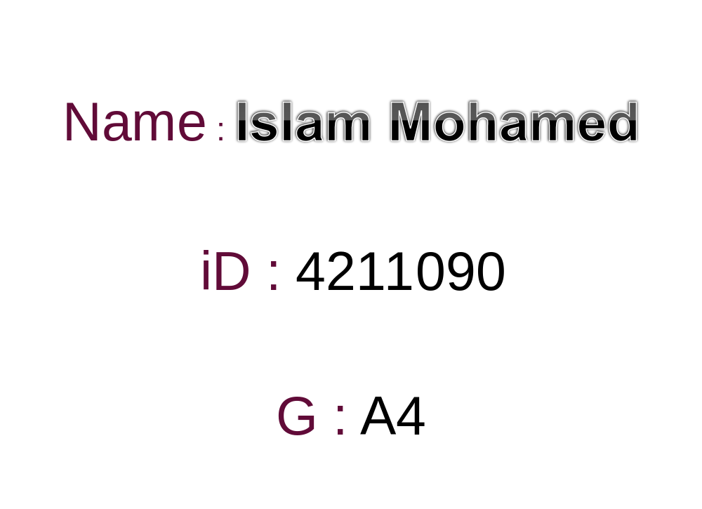

Q1) Make a research on MySQL storage engines with a brief explanation for each type?
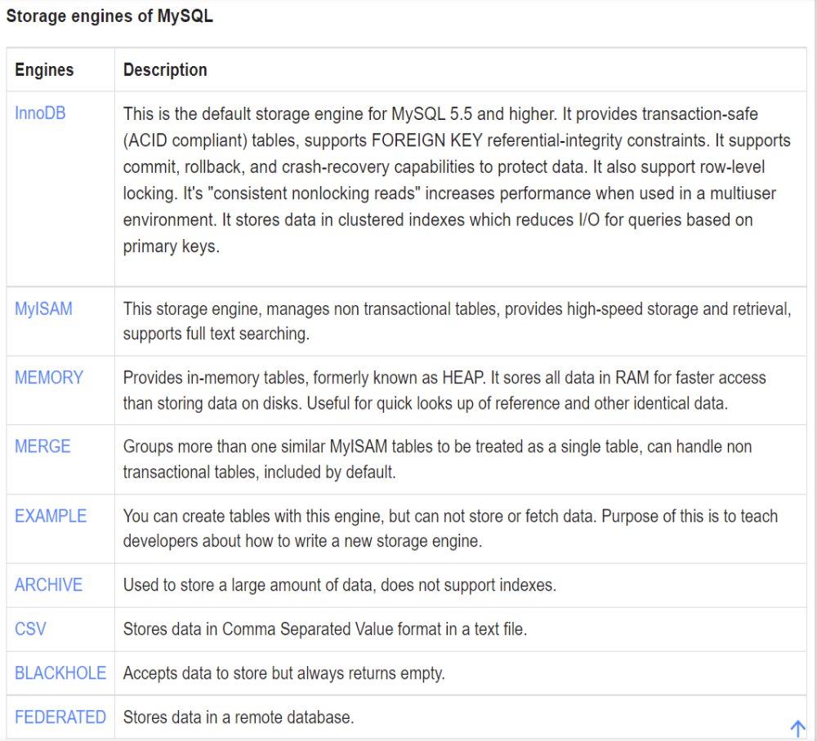
Storage engines are MySQL components, that can handle the SQL operations for different table types to store and manage information in a database.

Q2)
1-Create a database (Market)
2-Create tables in the image
3-Create a primary key for every table
4-Make relations between the tables using 5-foreign keys
